**ECO 304K Exam 3 Spring 2024 (11am)**

**Version: BD**

**Last Name: __________________**

**First Name: __________________**

**UT ID: __________________**

**Directions:** There are 40 questions on this exam. Each question is worth the same (1 point). You also **MUST SKIP 3** questions, which are automatically counted correct. For each multiple-choice question, select the best response. For each short answer question, you can earn 1/2 credit if your answer is incorrect, but you explain your reasoning/show your work. This is a closed book, closed notes exam. You may use a physical calculator but may not use a cell phone or any other electronic device during the exam. Make sure you write your full name and UT ID above. Hand in your exam and show your student ID to the TA when turning in your exam. Good luck!

**\*\*\*Write the word SKIP next to three questions\*\*\***

**Multiple-Choice Answers: Short Answers:**

**1. ___D_____ 17. ___B_____ 33. 0.9____________**

**2. ___C_____ 18. ___D_____ 34. $10 billion____________**

**3. ___B_____ 19. ___B_____ 35. $24,000____________**

**4. ___A_____ 20. ___A_____ 36.** GDP: **lowers____________**

**5. ___A_____ 21. ___B_____** Unemployment: **raises___________**

**6. ___B_____ 22. ___C_____** Price Level: **lowers__________**

**7. ___C_____ 23. ___B_____ 37. Circle one choice**

**8. ___A_____ 24. ___D_____** P1

**9. ___A_____ 25. ___A_____** P2

**10. __C______ 26. ___B_____ P3**

**11. __B______ 27. ___B_____ 38. Yen: 31,250___________**

**12. __C______ 28. ___D_____ 39. Canada’s opp cost:_2 cars________**

**13. __A______ 29. ___B_____ 40. 18_______ cars**

**14. __B______ 30. ___D_____ 44_______ tons of paper**

**15. __D______ 31. ___A_____**

**16. __A______ 32. ___D_____**

**For Graders**

**Correct SA: ____ + Partial Credit: ____ x 1/2 ____ = Total SA Points: ____**

**TOTAL POINTS: MC: _____ + SA: _____ + 3 SKIPS = /40**

**1. During which of the following situations would the government most likely have an expansionary fiscal policy?**

A) When the volume of imports is unusually low.

B) When the economy is in the upswing phase of a business cycle.

C) When the inflation rate is running unusually high.

**D) When the unemployment rate is running unusually high.**

**2. When aggregate demand is high enough to drive unemployment below the natural rate:**

A) there is downward pressure on the price level, and the government may want to impose a contractionary fiscal policy.

B) the economy is slipping into a recession, and the government may want to impose an expansionary fiscal policy.

**C) there is upward pressure on the price level, and the government may want to impose a contractionary fiscal policy.**

D) there is upward pressure on the price level, and the government may want to impose an expansionary fiscal policy.

**3. A recognition lag happens because:**

A) it takes time to recognize the true long-run growth rate in the economy.

**B) it is difficult to determine when the economy is turning up or down.**

C) in most nations, one or more governing bodies must approve government spending or new tax policies.

D) it takes time for the complete effects of monetary and fiscal policy to materialize.

**4. Assume that the government is currently balancing the national budget so that outlays equal tax revenues. Then the economy starts to shrink, and the government decides to increase government spending by $50 billion. As a result, the federal budget will:**

**A) be in deficit by at least $50 billion.**

B) be in surplus by at least $50 billion.

C) remain balanced.

D) be in surplus by less than $50 billion.

**5. Research and development (R&D) tax credits:**

**A) encourage firms to spend resources to develop new technology, and so shift the long-run aggregate supply curve to the right.**

B) increase private firms’ incentive to spend on R&D and so shift the aggregate demand curve to the right.

C) reduce private firms’ incentive to spend on R&D and so shift the aggregate demand curve to the left.

D) discourage firms from spending resources to develop new technology, and so shift the long-run aggregate supply curve to the left.

**6. During a boom, unemployment will ______, tax revenue collected by the government will ______, and transfer payments paid by the government will _______.**

A) decrease; decrease; increase

**B) decrease; increase; decrease**

C) increase; increase; decrease

D) increase; decrease; increase

**Refer to the following graph to answer question 7.**

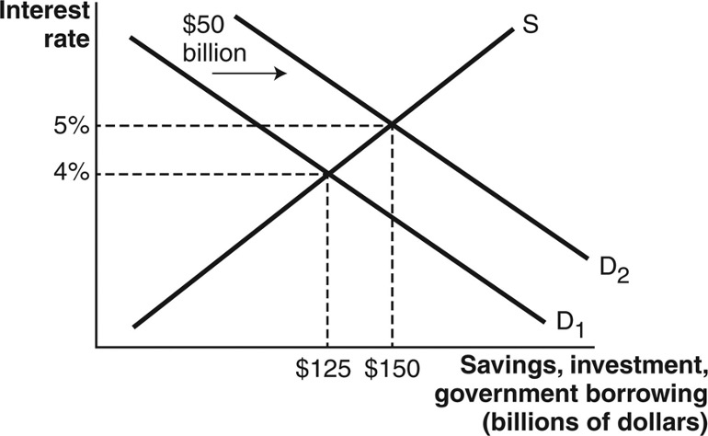

**7. According to the graph, private investment ________ as a result of crowding-out from government borrowing of $50 billion.**

A) increased by $50 billion

B) increased by $25 billion

**C) decreased by $25 billion**

D) decreased by $50 billion

**8. Federal Deposit Insurance (FDIC) creates a moral hazard problem in the banking system.**

**A) True.**

B) False

**9. What function of money is highlighted when Tsai pays her water bill with cash?**

**A) Medium of exchange.**

B) Liquidity.

C) Unit of account.

D) Store of value.

**10. Money serves as a unit of account when:**

A) sellers are willing to accept it in exchange for goods or services.

B) it can be easily stored and used for transactions in the future.

**C) prices of goods and services are stated in the monetary unit.**

D) all of these options are correct.

**11. What is the difference between commodity money and commodity-backed money?**

A) Commodity-backed money loses value if the commodity becomes more plentiful, whereas the commodity keeps its value.

**B) Commodity money is an actual good, whereas commodity-backed money is only exchangeable for an actual good.**

C) Commodity-backed money can easily lose value through government-induced inflation, whereas commodity money cannot.

D) Compared to commodity-backed money, commodity money is more convenient to store, transport, and exchange.

**12. What was the main goal of quantitative easing that started in 2008 and ran until late 2014?**

A) To prevent the collapse of the banking system.

B) To shrink the trade deficit between the United States and other nations.

**C) To stimulate the U.S. economy by increasing the money supply.**

D) To prevent interest rates from dropping below safe levels.

**13. What move by the Federal Reserve Bank (Fed) in 2008 reduced banks’ opportunity cost of holding excess reserves?**

**A) The Fed started paying interest on bank reserves deposited with the Fed.**

B) The Fed lowered the required reserve ratio and with it the required size of reserves.

C) The Fed made it easier for banks to lend reserves on deposit at the Fed to other banks.

D) The Fed made it illegal for banks to keep excess reserves in their own vaults.

**14. If an increase in the quantity of money leads to real growth in the economy, why would the central bank ever stop increasing the money supply?**

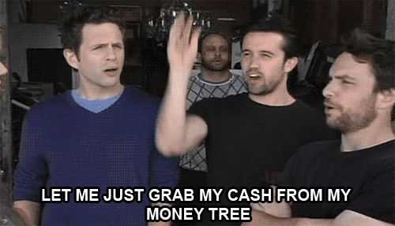

A) Although there is a short-run incentive to increase the money supply, these effects wear off in the long run as prices adjust and then drive up the value of money.

**B) Increasing the money supply only leads to growth when the policy is unexpected. When it is predictable, it just drives down the value of money.**

C) In the long run, uninterrupted economic growth eventually leads to rising unemployment.

D) Increasing the money supply is not a politically popular action and may lead to leaders of the central bank not getting re-elected.

**15. Which of the following best describes how contractionary monetary policy affects the aggregate demand curve in the aggregate demand–aggregate supply model?**

A) Contractionary monetary policy pulls money directly out of the loanable funds market. This lowers the interest rate, which provides a larger incentive for firms to invest. Investment is a component of aggregate demand, so this shifts aggregate demand to the right.

B) Contractionary monetary policy puts money directly into the loanable funds market. This lowers the interest rate, which provides a larger incentive for firms to invest. Investment is a component of aggregate demand, so this shifts aggregate demand to the right.

C) Contractionary monetary policy puts money directly into the loanable funds market. This raises the interest rate, which provides a larger incentive for firms to invest. Investment is a component of aggregate demand, so this shifts aggregate demand to the right.

**D) Contractionary monetary policy pulls money directly out of the loanable funds market. This raises the interest rate, which provides a lesser incentive for firms to invest. Investment is a component of aggregate demand, so this shifts aggregate demand to the left.**

**16. The widespread problems in financial markets during the Great Recession negatively affected key institutions in the macroeconomy. In addition, the financial regulations that were put in place restricted banks’ ability to lend at levels equal to those in effect prior to 2008. This resulted in a ________ shift of the ________ curve.**

**A) leftward; long-run aggregate supply**

B) rightward; long-run aggregate supply

C) rightward; aggregate demand

D) rightward; short-run aggregate supply

**17. The real wages of workers on long-term contracts will increase under expansionary monetary policy.**

A) True

**B) False.**

**18. The Federal Reserve:**

A) increased the federal funds rate during the Great Recession and decreased the federal funds rate during the COVID recession.

B) decreased the federal funds rate during the Great Recession and did not change the federal funds rate during the COVID recession.

C) decreased the federal funds rate during the Great Recession and increased the federal funds rate during the COVID recession.

**D) decreased the federal funds rate during both the Great Recession and the COVID recession.**

**19. When the Federal Reserve buys bonds from financial institutions, new money moves directly:**

A) out of the loanable funds market.

**B) into the loanable funds market.**

C) into the hands of consumers.

D) out of the hands of consumers.

**20. In the domestic market, following the removal of an import quota, imports ________, domestic production ________, and prices ________.**

**A) increase; decreases; decrease**

B) decrease; increases; decrease

C) decrease; decreases; increase

D) increase; increases; increase

**21. Which of the following claims is true?**

A) The U.S. has a trade deficit in both goods & services trade.

**B) The U.S. has a trade deficit in goods but a surplus in services trade.**

C) The U.S. has a trade surplus in both goods & service trade.

D) The U.S. has a trade surplus in goods, but a deficit in services trade.

**22. If a country imposed a tariff on imported beef, what would be the effects on the country’s market for beef?**

A) After the tariff, the price and quantity of beef will increase. Imports of beef will decrease. Domestic producers will benefit because they produce more and can charge a higher price.

B) After the tariff, the price and quantity of beef will decrease. Imports of beef will increase. Domestic producers will be hurt because domestic production will fall and charge a lower price.

**C) After the tariff, the price of beef will increase and quantity of beef will decrease. Imports of beef will decrease. Domestic producers will benefit because they produce more and can charge a higher price.**

D) After the tariff, the price of beef will decrease and quantity of beef will increase. Imports of beef will increase. Domestic producers will be hurt because they will produce more and charge a lower price.

***Use the following scenario to answer questions 23-25***

***Two small island economies, Niue and Pitcairn, produce two tropical fruits, mangos and jackfruit. Niue can produce 60 mangos per hour or 30 jackfruit per hour. Pitcairn can produce 20 mangos per hour or 25 jackfruit per hour.***

**23. Based on the scenario, which of the following is true?**

A) Pitcairn has a comparative advantage in mangos.

**B) Niue has a comparative advantage in mangos.**

C) Niue has a comparative advantage in jackfruit.

D) Niue will specialize in the production of jackfruit with trade.

**24. Based on the scenario, which of the following is true?**

A) Pitcairn’s opportunity cost of a jackfruit is one mango.

B) Pitcairn’s opportunity cost of a jackfruit is four-fifths of a mango.

C) Niue’s opportunity cost of a jackfruit is two mangos.

**D) Both B and C are correct.**

**25. Based on the scenario, what most likely will occur if these two countries engage in trade with each other?**

**A) Total joint output will be 25 jackfruit and 60 mangos.**

B) Total joint output will be 30 jackfruit and 20 mangos.

C) Total joint output will be 55 jackfruit and 80 mangos.

D) Total joint output will be 27.5 jackfruit and 40 mangos.

**26. Why would a country devalue its own currency?**

A) To become more dependent on other countries’ imports.

**B) To make its exports more attractive to foreign countries.**

C) To retaliate against countries with overvalued currency

D) To decrease the price of imports it purchases from other countries

**27. If the U.S. current account is in deficit, the U.S. capital account is in deficit.**

A) True

**B) False.**

**28. Suppose an American citizen purchases a set of headphones from Ultrasone, a German company. Ultrasone then uses the dollars to purchase U.S. Treasury bonds. How will the two movements of currency impact the U.S. trade deficit?**

A) The headphone purchase is recorded as an export in the current account, so the trade deficit will decrease.

B) The headphone purchase is recorded as an import in the current account, so the trade deficit will decrease.

C) The headphone purchase is recorded as an export in the current account, so the trade deficit will increase.

**D) The headphone purchase is recorded as an import in the current account, so the trade deficit will increase.**

**29. How can strong economic growth cause a current account deficit?**

A) A strong economy means a larger supply of domestic goods, which increases exports.

**B) A strong economy means consumers can afford more imports.**

C) A strong economy permits increased savings.

D) A strong economy causes a government budget surplus.

**Use these graphs to answer the next question.**

**The following two graphs depict the equilibrium price of a pound of Kentucky flax seed sold in Kentucky and West Virginia, respectively. Assume the type and quality of the flax seed being sold in the two states are identical. Further, assume flax seed sellers incur zero costs to transport flax seed between the two states and that there are no other barriers to trade.**

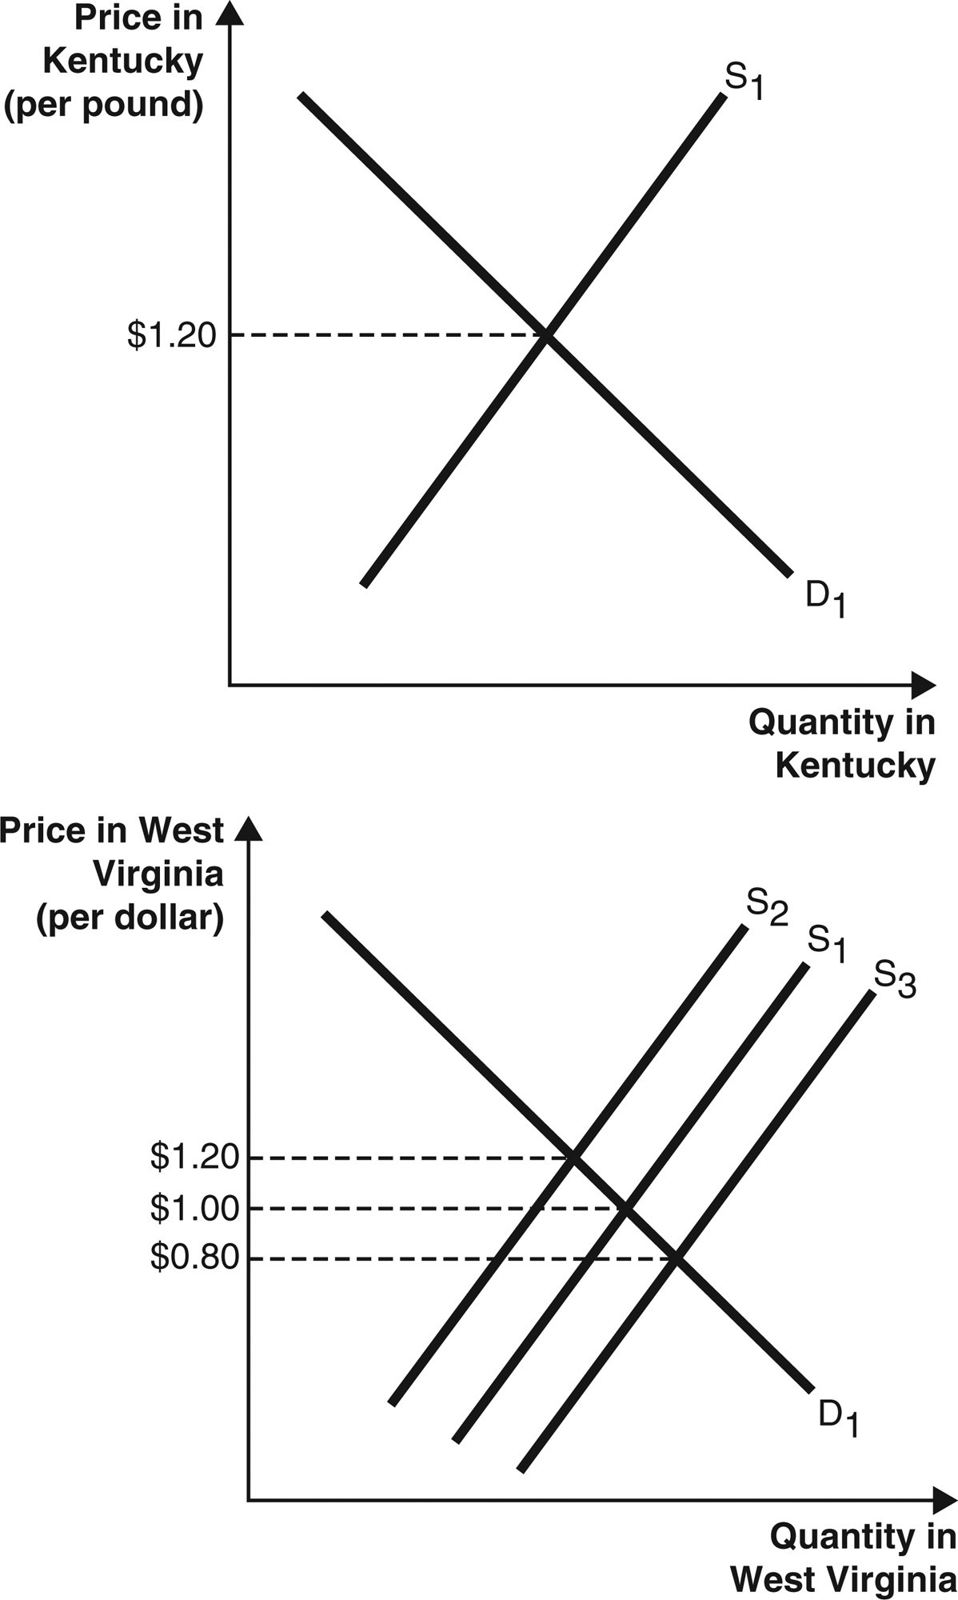

**30. Suppose the price of a pound of flax seed in West Virginia is currently $1.00. The law of one price suggests that, because the price of a pound of flax seed is $1.20 in Kentucky, the price of a pound of flax seed will be ________ in West Virginia after sellers adjust their supplies in both markets.**

A) $1.20

B) $1.00

C) $0.80

**D) between $1.20 and $1.00**

**Use these graphs to answer the next question.**

**The following two graphs depict the demand and supply of U.S. dollars and the demand and supply of British pounds in the foreign currency exchange market.**

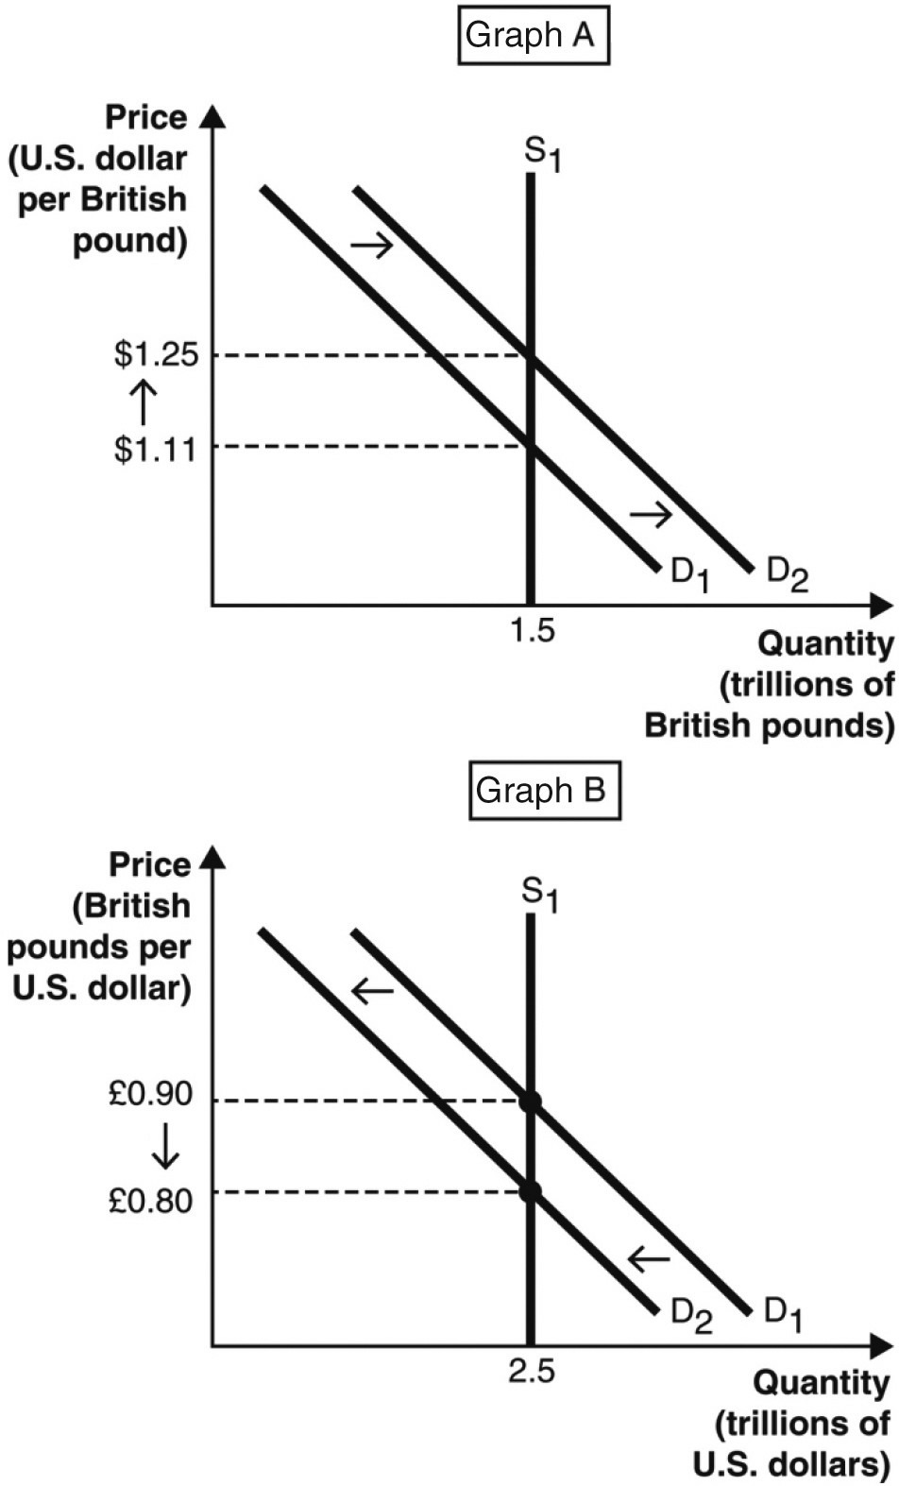

**31. An increase in U.S. consumer demand for British goods is consistent with:**

**A) both Graphs A and B.**

B) neither Graph A nor Graph B.

C) Graph A but not Graph B.

D) Graph B but not Graph A.

***Use the table to answer the next question.***

***The following table shows the number of U.S. dollars required to buy one Japanese Yen between August 1, 2023 and November 1, 2023.***

|  |  |
| --- | --- |
| **Date** | **U.S. Dollars Required to Buy 1 Japanese Yen** |
| August 1, 2023 | 0.00919 |
| September 1, 2023 | 0.00941 |
| October 1, 2023 | 0.00925 |
| November 1, 2023 | 0.00926 |

**32. Between September 1, 2023 and October 1, 2023, the number of Japanese goods exported to the United States likely:**

A) decreased because Japanese goods became more expensive to consumers in the United States.

B) increased because Japanese goods became more expensive to consumers in the United States.

C) decreased because Japanese goods became less expensive to consumers in the United States.

**D) increased because Japanese goods became less expensive to consumers in the United States.**

**Enter your answers for the short answer section on the Answer (front) page.**

**33. If the spending multiplier is 10, the marginal propensity to consume (MPC) in the economy is: _______**

**Answer:** 0.9

1/(1-MPC) = 10

MPC is 0.9

**Refer to the following graph to answer the next question, where LRAS is long-run aggregate supply, SRAS is short-run aggregate supply, and AD is aggregate demand.**

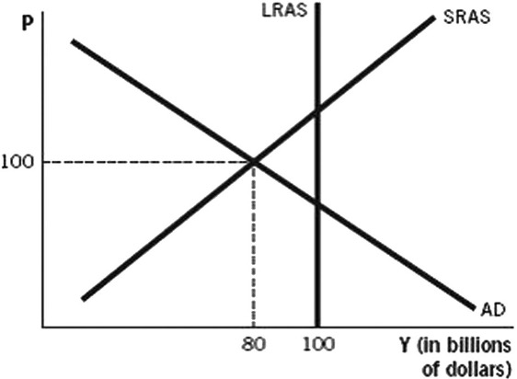

**34. According to the graph above, and assuming the marginal propensity to consume is 0.5, to shift aggregate demand back to the long-run equilibrium, the government would have to increase government spending by: _______**

**Answer**: $10 billion.

Multiplier is 1/(1-MPC)

1/(1-0.5)

1/0.5 = 2

$10 billion x 2 = $20 billion

**35. If banks have a required reserve ratio of 25%, and one bank is currently holding $6,000 in excess reserves, what would be the maximum impact on the money supply if the bank loans out all of the excess reserves?**

**Answer: $24,000**

Money multiplier = 1/required reserve ratio

1/0.25 = 4

$6,000 x 4 = $24,000

**36. In the short run, contractionary monetary policy ____________ real gross domestic product (GDP), ____________ unemployment, and ____________ the price level.**

**On the front page, write “raises”, “lowers” or “does no change” for each variable.**

**Answer:** lowers; raises; lowers

**37. According to the graph, if an expansionary monetary policy is fully expected, and the economy starts initially in full-employment equilibrium, in the long run, the price level will be _____.**

**On the front page, circle P1, P2, or P3.**

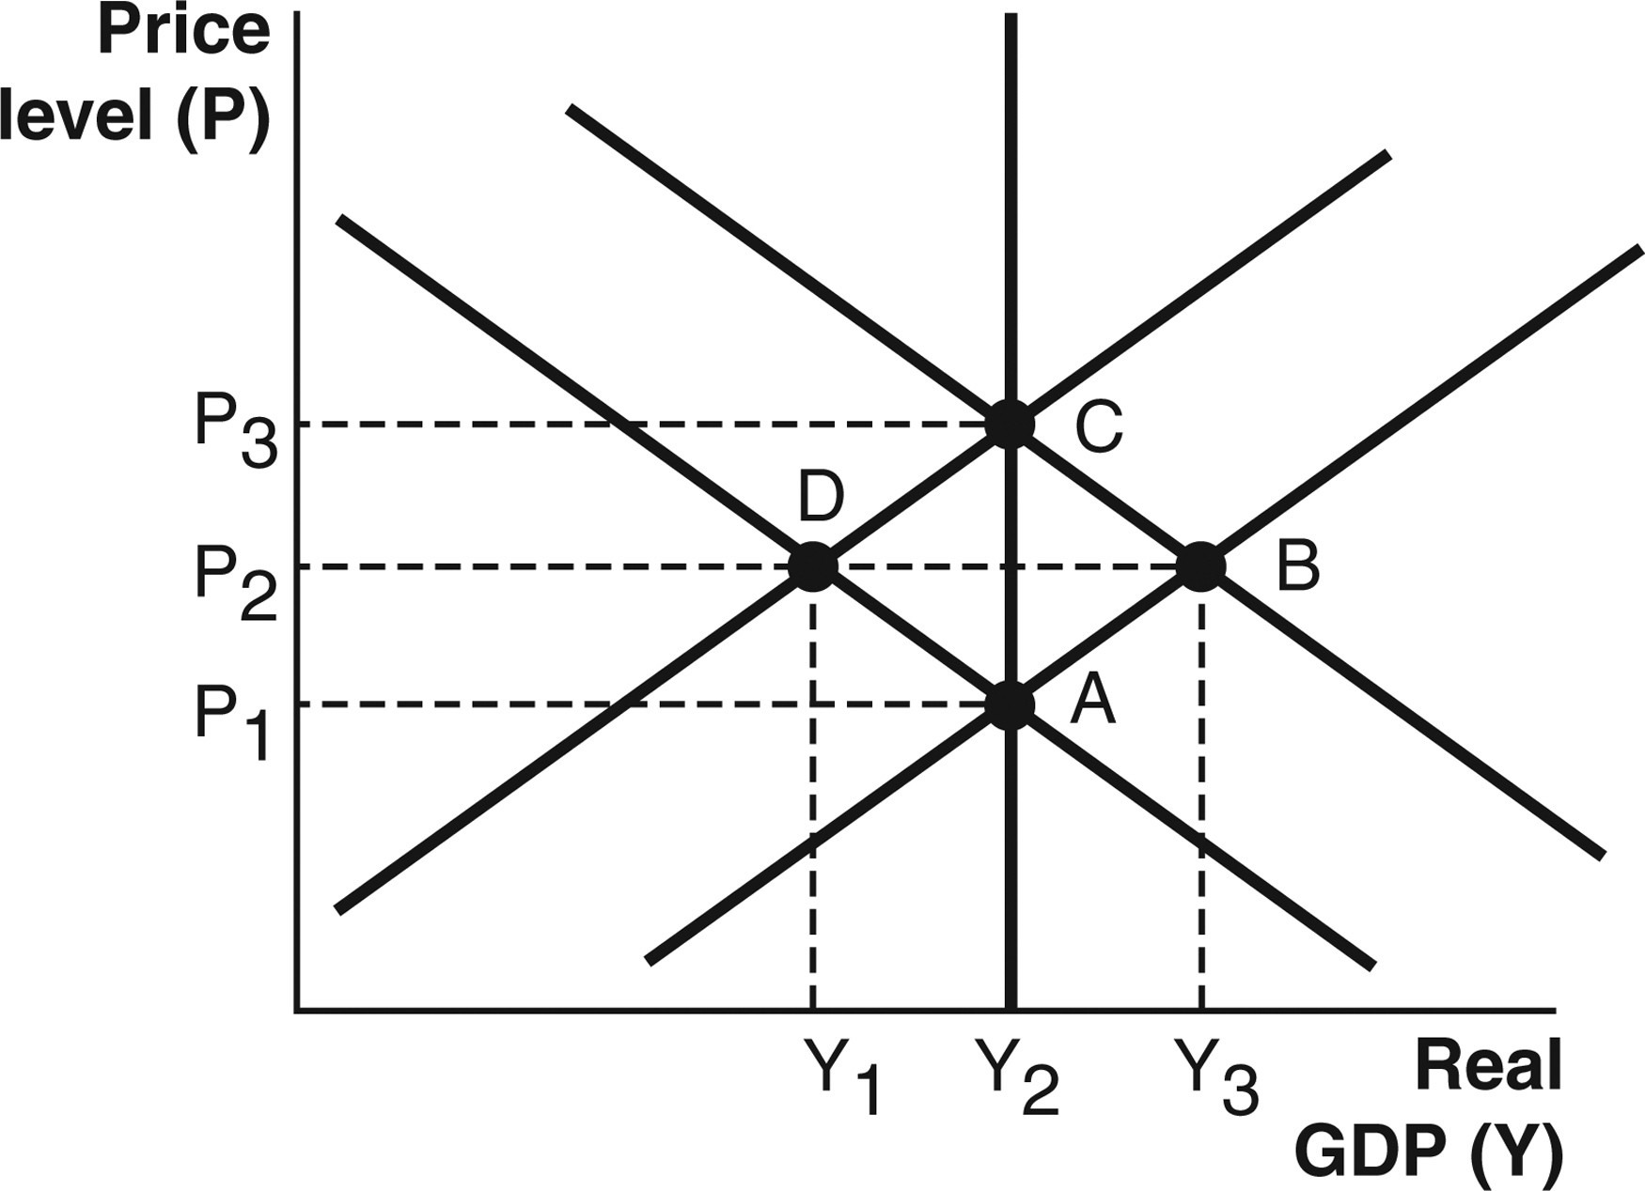

**Answer:** P3.

**38. Assuming the theory of purchasing power parity holds, if the exchange rate between the United States and Japan is $0.008 per yen (¥), then how much does a $250 Microsoft Xbox cost in Japanese yen?**

**Answer:** ¥31,250

$250/0.008 = ¥31,250

**The following graph illustrates the production possibilities for two countries, Russia and Canada. Please use this graph to answer questions 39-40.**

**Assume that initially, the two countries do not trade. Russia produces 40 cars and 5 tons of paper. Canada produces 16 cars and 42 tons of paper. You can assume cars and paper are measured in thousands of units.**

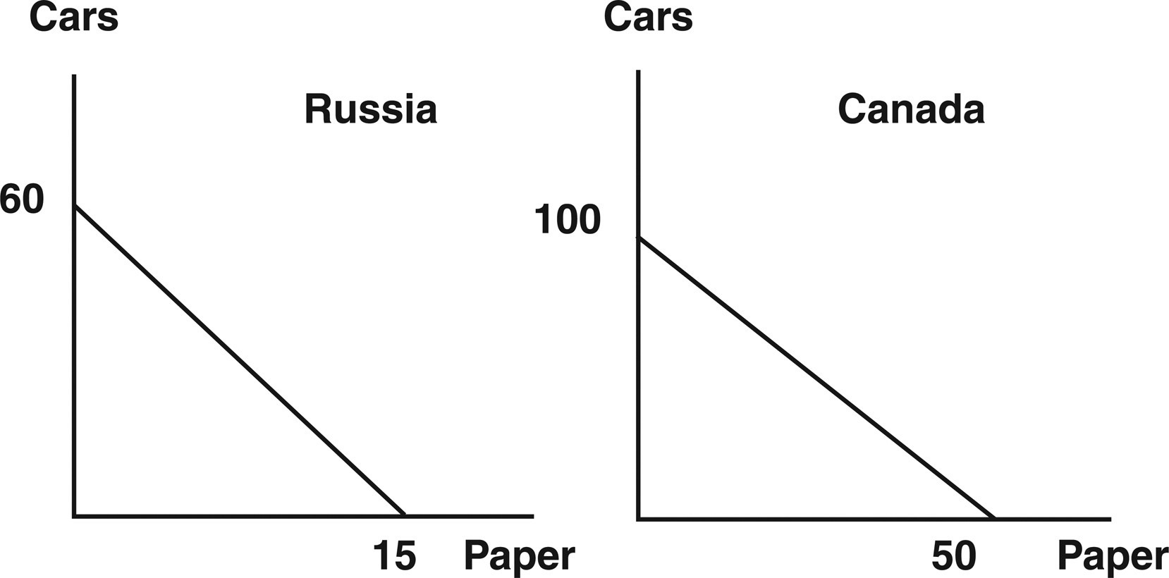

**39. What is Canada’s opportunity cost of producing 1 ton of paper?**

**Answer**: 100/50, or 2 cars.

**40. Suppose the two countries decide to completely specialize and trade. If they decide to trade 18 cars in exchange for 6 tons of paper, then after trade, Canada will be able to consume ________ cars and ________ tons of paper.**

**Answer**: 18 cars and 44 tons of paper.

Canada makes 50 tons of paper and no cars. A trade of 18 cars for 6 tons of paper leaves Canada with 18 cars and 44 tons of paper.